

**Spécifications Techniques Détaillées**

**Outil d'Aide au Décisionnement**

VERSION 1 DU 31 oct 2016

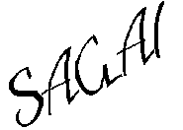

INDEX DES REVISIONS:

|  |  |  |  |
| --- | --- | --- | --- |
| **Revision** | **Author** | **Date** | **Content** |
| 1.0 | F. ROMERO | 31/10/2016 | Creation |
|  |  |  |  |
|  |  |  |  |
|  |  |  |  |
|  |  |  |  |

**Links to related documentation**

[Spécifications Fonctionnelles Détailles](http://docinfogroupe.inetpsa.com/ead/doc/ref.20656_13_17500/v.2.21/nPj.1)

[JIP 2.4.4](http://infodev.inetpsa.com/opencms/opencms/com.inetpsa.idcenter/produits/IDE/JIP)

[LEGO 3.10.1](http://jip.inetpsa.com/projects/fwk00/current/root/)

[W20 1.3.2](http://community.seed.dev.inetpsa.com/w20-doc-latest)

[REST (Jersey 1.9.1)](http://docinfogroupe.inetpsa.com/ead/dom/view.action?domId=205536499)

[Appel d'un Webservice depuis CICS](http://infodev.inetpsa.com/opencms/opencms/com.inetpsa.idcenter/accueil/ressources/documentation/contents/document0076)

[Prototype Portail Décisionnement](http://yvavb250/UCD/PortailDecisionnement/#/screens/d12245cc-1680-458d-89dd-4f0d7fb22724)

**Table des matières**

1. Description Générale

We displayed the “remplaḉante” part in traitement accords and traitement des dc.

1. Limites fonctionnelles

This change affected the “traitement des dc” & “traitement accord” forms.

1. TECHNICAL ASPECTS

They are the affected resources for this change:

|  |  |
| --- | --- |
| traitementAccord.jsp | We added a new field. |
| TraitementDesDCController.js | We modified the affected methods. |
| traitementDesDC.jsp | We added a new field. |
| TraitementAccordController.js | We modified the affected methods. |
| PieceIncidentDebiteDto | We add a getter & setter to obtain & modify the replacing piece respectively. |
| PieceIncidentDebite | We add a getter & setter to obtain & modify the replacing piece respectively. |
| PieceIncidentDebiteDaoImpl | We modified a method. |
| AccordOperationPr | We add a getter & setter to obtain & modify the replacing piece. |
| AccordOperationPrDto | We add a getter & setter to obtain & modify the replacing piece. |
| AccordOperationPrAssembly | We modified two methods. |
| AccordOperationPrDaoImpl | We modified a method. |

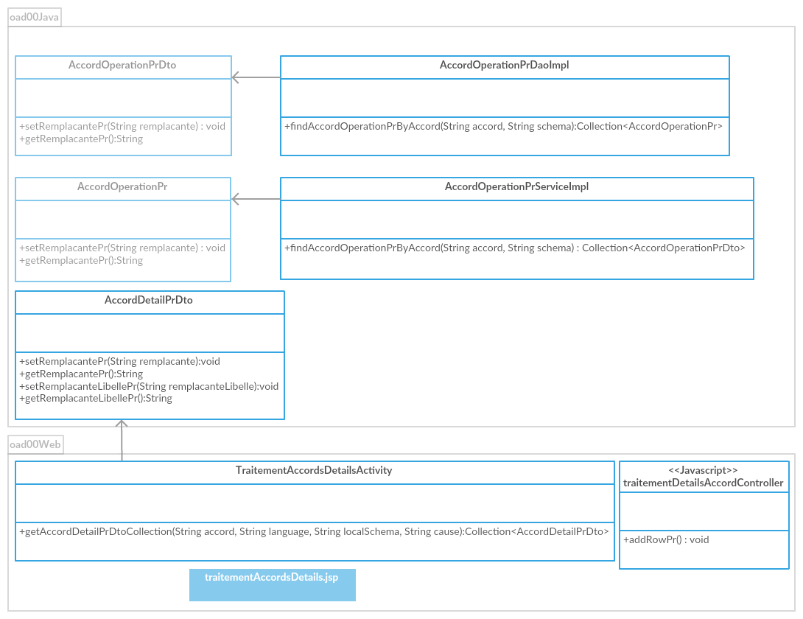

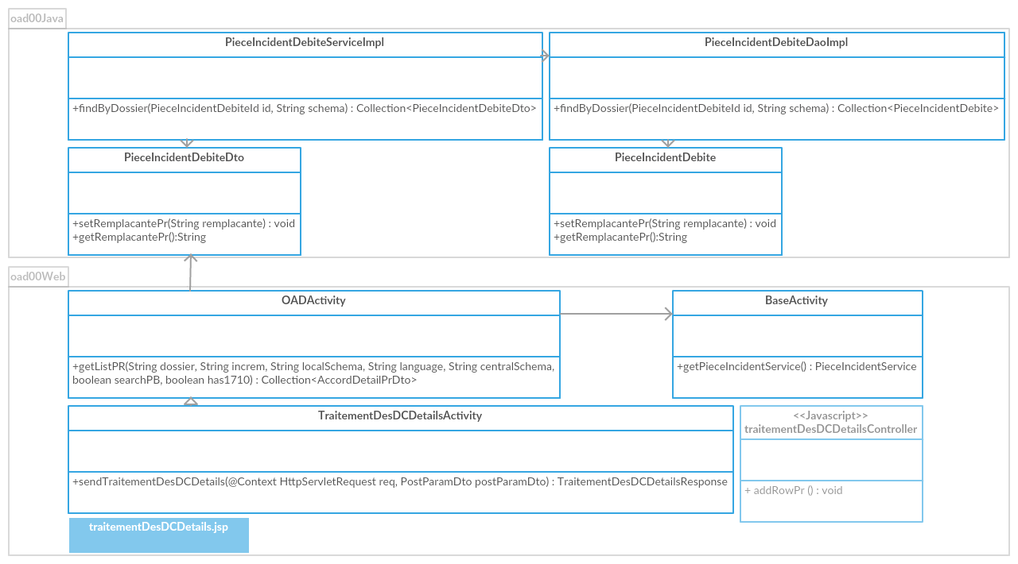

1. UtilisateurS de l’application



1. Contexte du système



1. Modèle de donées physique



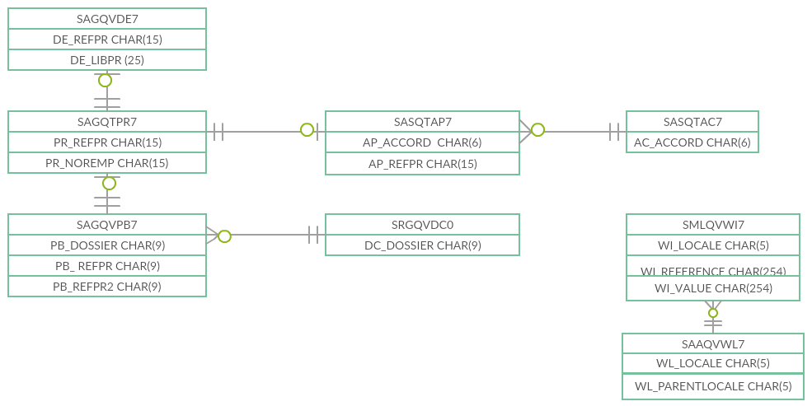

1. Modèle de donées conceptual



1. Cas d’utilisation

## 

## 